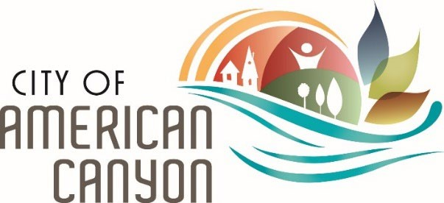

**Pool Party Guidelines**

Thank you for choosing the Philip West Aquatic Center for your party needs! We can’t wait to celebrate with you!

**Pool Party Locations:**

* *Splash Zone:*Located in the grass area near the kiddy pool.
* *Splash Bash:* Located in the grass area near the fence and parking lot.

**Set Up and Cleanup:**

The Pool Party Applicant may arrive 30 minutes prior (Fridays at 1:00pm, and Saturdays at 12:30pm) to the start time of Public Swim to setup their pool party. No additional guests will be allowed into the facility; pool party guests may enter the facility at the start time of Public Swim (@1:30pm on Fridays, and @1pm on Saturdays). Pool Party Applicants are encouraged to clean their areas throughout the duration of their party. Applicants will have 15 minutes once Public Swim has concluded to cleanup their pool party area and exit the facility. Trash is to be placed in appropriate trash receptacles, decorations and supplies are to be removed from the facility, and any large spills or debris is to be cleaned up and taken away. Applicants who fail to properly clean their pool party area may lose a portion or all of their refundable deposit.

* Friday Pool Parties conclude at 4:00pm
* Saturday Pool Parties conclude at 5:00pm

**Party Decorations:**

Applicants may decorate their pool party area with their own decorations. The City of

American Canyon will provide two (2) six-foot tables, one (1) 10x10 popup canopy, and 16 chairs. Applicants may bring in additional tables, chairs, and popup canopies for their guests. The following items are not permitted into the facility:

* Glitter, confetti, etc.
* Flotation devices (noodles, balls, etc.), squirt guns, or water balloons.
* Piñatas.

**Guests:**

Our Public Pool Parties includes the total of 17 guests into the facility. Applicants may add an additional 13 guests at the resident rate of $4 per person ($5 for nonresidents) to their pool party, with a maximum capacity of 30 guests. Anyone attending the pool party must be included in the head count; this includes parents and non-swimmers. All guests will be required to follow all reasonable verbal direction from City staff, and posted facility and pool rules. Participants who are not yet potty trained will be required to wear a swim diaper while swimming. Children five (5) years and under will be required to be within arms reach of a parent/guardian; and children 12 years and under must be accompanied by a parent/guardian to enter the facility.

**Food and Beverages:**

Applicants will have the ability to bring their own food and beverages, and serving and eating utensils. The City of American Canyon will have the ability to store one (1) basic sheet cake per party in a refrigerator; please inform City staff at the time of arrival. The following items are not permitted into the facility:

* Barbeques.
* Alcoholic Beverages.
* Sharp objects.
* Glass of any kind: containers, drinking ware, soda bottles, etc.

All coolers are subject to checking for any glass containers.

**Further Questions:**

Please feel free to contact us with any further questions you may have at (707) 648-7275.